Customer Experience: In-Person Delivery Order

Wonder what customers see when they get your invitation to purchase cookies?


A customer receives a girl’s email announcing that cookie season is open. The customer clicks the “Buy Cookies Online” link and is taken to the girl’s Digital Cookie site.

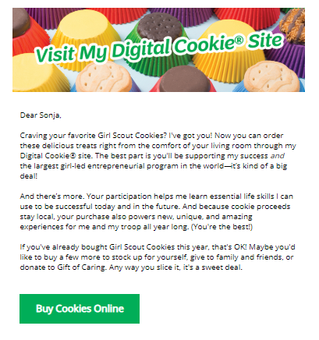


As the customer orders boxes, the total amount updates.
Once the order is completed, the customer selects the delivery method.
As the customer orders boxes, the total amount updates. Once the customer has selected the cookies she wants, she can click the “Have Girl Scout Deliver the Cookies in Person” option.
Once the customer is satisfied with her order, the customer simply clicks the “Checkout” button.

Customer enters box quantity

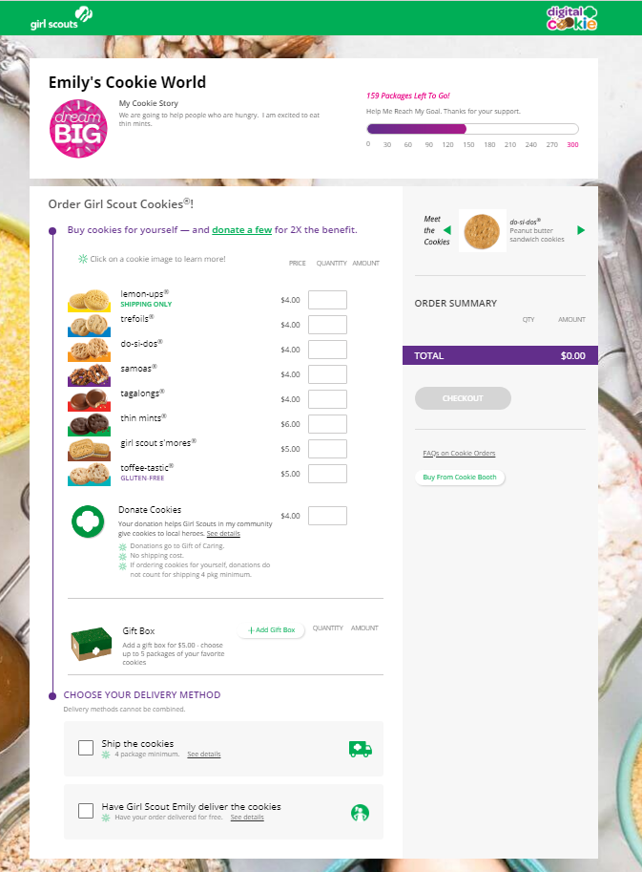
Checkout

Select Delivery Method


The customer is taken to a checkout screen to complete basic shipping and billing information.
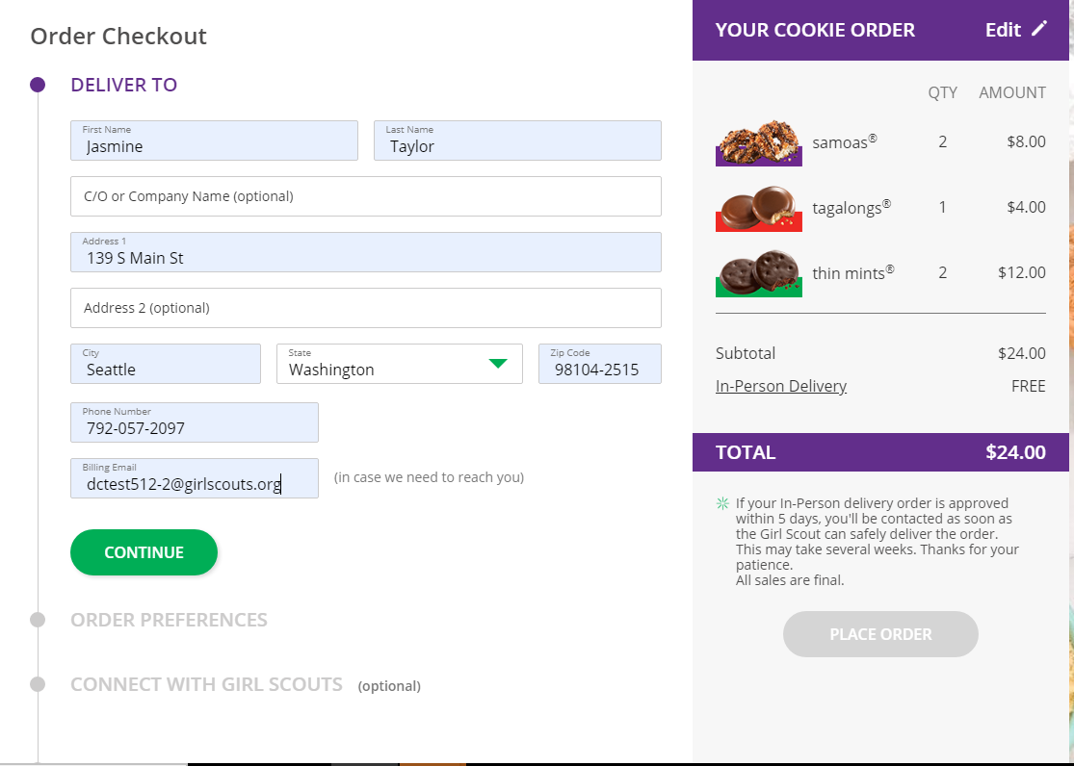

The next screens ask customers to:
- Complete credit card information.
- Choose a second option if Girl Delivery is not approved.
- Share if they were Girl Scouts. (optional)
- Indicate if they want membership or volunteer information (optional)

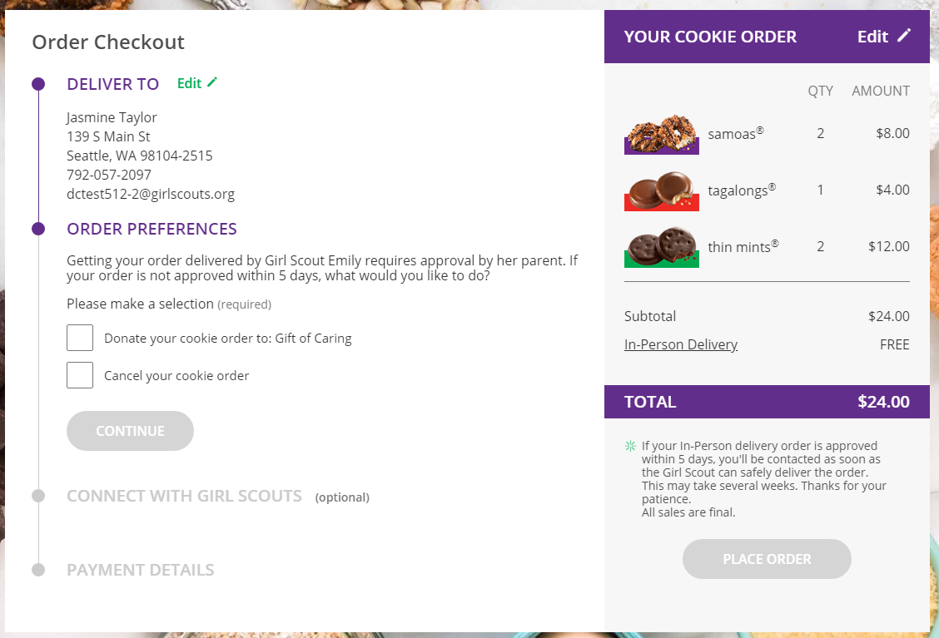

Once the customer has completed the information, they click the “Place Order” button on the right side.


The customer then sees an order confirmation screen that includes the option of placing a new order in case they want to send some to a friend!

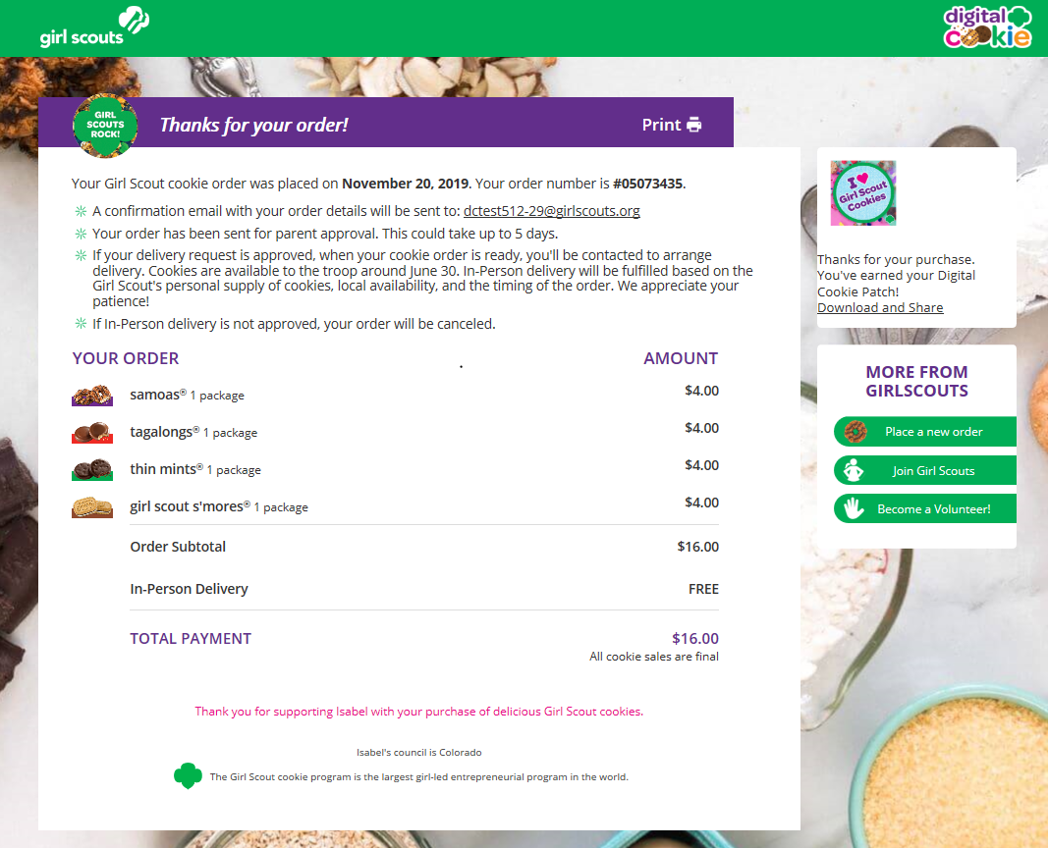


Customers will receive a series of emails about their order.

The first is an order confirmation letting them know that their order is pending approval from the parent.

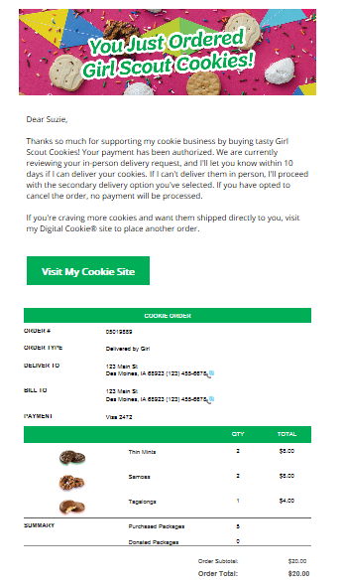

Then an email is sent indicating the order has been approved. If the order has been declined, an email is sent to notify the customer and give them the option to place a new order to have cookies shipped or donated.

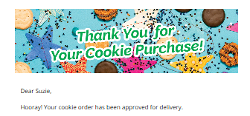
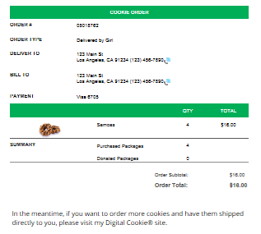

An email thanking the customer for their support and asking them to complete a quick survey can be sent by the girl at the end of the sale.
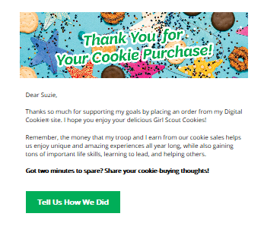

If the order is a donation or contains a donation, the emails will reflect that as well.

Remind your Girl Scout a personal note helps create a satisfied customer who is likely to purchase cookies from her again.

